**MACM 316 – Computing Assignment 7 Report**

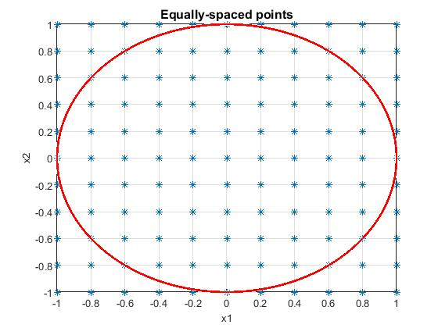

As shown on the top left hand corner figure, the error of polynomial interpolation at equally-spaced nodes increases when more nodes are taking into the calculation of interpolation. Although the efficiency is high since it only takes short instant to run this part of the code, its robustness and accuracy are not at satisfactory at all. In terms of accuracy, as we have seen in class and also from the figure, the end points of the interval are not well suited when we are taking polynomial interpolation at equally spaced nodes, which causes the accuracy decreases when higher degree polynomial interpolations are taking into account. This is known as the Runge’s phenomenon. On the other hand, in terms of robustness, it is no where near the machine epsilon, therefore this is not robust at all.

Using the so-called greedy algorithm to generate the nodes showing on the top right hand corner figure. We can see that the equally-spaced nodes that were generated previously are plotted linearly, but nodes that are generated using the greedy algorithm are non-linear. These nodes result in an overall better polynomial interpolation as higher degree polynomial interpolations are taking into account. As shown on the second figure on the left hand side, using greedy nodes to do polynomial Interpolation gives us a really robust result when

the error drops down to nearly machine epsilon as 80 nodes or greater are taken into the calculation of polynomial interpolation. This also justifies that the accuracy is high. Trade-off of this is the polynomial interpolation with greedy nodes does not have a good efficiency because it contains great amount of FLOPS when maximizing the function V(x) in the process of calculating the polynomial interpolation. After all,